June 26th, 2017

**FREE**

*Minburn Moments*

Formerly the Pinhook Page

United Methodist Church

3 Day "Camp Grounded"

Adult Church Camp

July 21-23rd

21st- Opening Service, Games, Crafts & Campfire

Meek Park 7-10pm

22nd- Ice Cream Social & Movie Night 7pm

Minburn UMC Fellowship Hall

23rd- Special Service w/Guest Speaker &

Praise Band

Minburn UMC 11am

The Minburn 4th of July Celebration

Downtown Minburn

Minburn UMC will be serving cinnamon rolls at the food stand at 7:30am

followed by the parade at 9:00.

Check out the Minburn City Website for more details

Community

Calendar

June

27th- Open Skating

7-9pm Meek Park

29th- Open Skating

7-9pm Meek Park

30th- Yoga 9:30am

Meek Park

BLANK PARK ZOO

10am- Legion Hall

JULY

3rd- Meet me in Minburn Concert

Music by Exit 113

Meal by Friends of the Library- Walking Tacos

at Food Stand

Library- Closed

4th- 4th of July Celebration- Downtown Minburn

UMC Cinnamon Rolls @ Meek Park 7:30am

Library-Closed

7th- Yoga 9:30am

Skate Time 10-Noon

Meek Park

10th- Build a Story

11:00am Legion Hall

12th- Newspaper Tower Building Challenge 1:00pm

Meek Park

Craft Club- 7:00pm

Legion Hall

Lula Roe Fundraiser

13th- Lego Club

6-7pm Legion Hall

14th- Yoga 9:30am

Skate Time 10-Noon

Meek Park

16th- UMC Potluck & Making of Ice Cream after 11am Service

Minburn Community Betterment Group

Summer Concert Series

July 3rd- Music by Exit 113

Meal provided by The Friends of the Minburn Library 5:30-7:30pm

August 5th- Music by Ma Deuce 7-9pm Meal provided by Minburn Fire Department 5:30-7:30

The Minburn

Public Library

wishes

Everyone a Safe

and

Happy

Independance

Day!

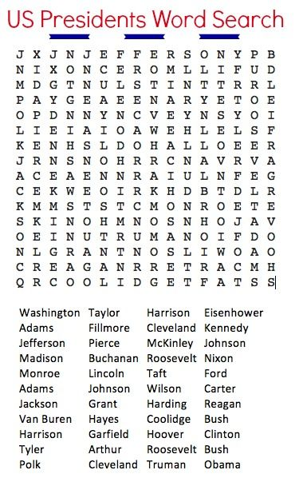



Saturday Morning

blood pressure checks are being postponed until further notice. Please stay tuned to see when they are being started again!

FREE Open Skating

Tuesday & Thursday nights 7-9pm

Meek Park Skating Rink

Skates Provided

Area Churches

**United Methodist**

**Church**

Church Service 11am

**Washington Chapel Church of Christ**

Sunday School 9:30am

Church 10:30am



# Have something to announce or advertise? How about something to sell? Put it on the Minburn Moments page!

# Contact Nicole at The Minburn Library call

# 515-677-2712 , email library@minburnlibrary.com or stop by I would be glad to add it in the next issue. Currently bi-monthly production.

City Hall Hours

Mon,Tue,Thur,Fri-

8am- Noon, 1-5pm

Wednesdays- Closed

Sat and Sun - Closed

515-677-2245

Minburn Public Library's Board of Trustee's is looking to fill a spot on the library board. If you are interested please contact the library at

515-677-2712 or

library@ Minburnlibrary.com

LEGO Club

July 13th

6:00-7:00

All ages welcome! Lego's and Duplo blocks will be provided.

No Charge

Newspaper Tower Building Challenge

July 12th, 2017

1:00pm- Meek Park Skating Rink

rain location Minburn Legion Hall

Build A Bot

June 25th

10:00am

Minburn Legion Hall

Supplies will be provided

**Library** hours

Monday-12-5:30pm

Tuesday- 12-5:30pm

Wednesday- Closed

Thursday- 12-5:30pm

Friday- 12-6pm

Saturday-

9am-Noon

515-677-2712

Friday Funday's

Yoga at 9:30am

Open Skating time

10:00am-Noon!

We do beginner kids Yoga, I have printouts for everyone!

There is no charge, skates and roller blades are provided

come join the fun!

Back by popular demand!

Michael Oz Magic Show!

July 20th

6:00pm

Minburn Legion Hall

Sizzling Storytime!

Join us monday afternoons at 3:00pm for some pint sized fun!

we will sings songs, and read books

geared toward ages 0-4

all ages are welcome

*Craft Club*

*July 12th, 2017*

*7:00pm*

*Minburn Legion Hall*

Craft Club is a week later due to the Holiday

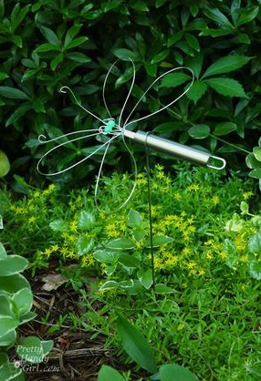

*Dragon Fly Yard Ornaments*

*We are having a LuLa Roe Fundraiser! The Morrill Family will be on hand selling their Lula Roe merchandise as a fundraiser for the Library's Craft Club. Stop by even if you don't want to craft and ch* 



**Book Club**

**Discussion**

July 17th 6:30pm

July 18th 11:00am

**The Summer Book**

**By: Tove Jansson**

**Everyone is welcome!**

**books are available at the library to be checked out**

**August- Miracles from Heaven**

**By: Christy Beam**

This publication is brought to you by Minburn Public Library

Stay Tuned to this newsletter and our website...

**www.minburnlibrary.weebly.com**

so you don't miss out on the upcoming events here at

Minburn Public Library!

Reading

Rules



Library News