Minburn Moments

FREE!!

December 2020

Area Churches

United Methodist Church

Wednesday Club

Wednesdays 5:30- 7:00pm

Church Service: New Time 10:30am Sunday

Washington Chapel

Church of Christ

Sunday School 9:30am

Church Service 10:30am Sunday

Veterans Day Supper

November 11th

5-7pm

Minburn Legion Hall

Take and Go Supper

Pulled pork sandwiches, cheesy potatoes, baked beans, cookie and drink

**Thanksgiving Word Scramble**

1. dalas____________________________________

2. wallcose_________________________________

3. drabe___________________________________

4. cribcool_________________________________

5. vargy___________________________________

6. Sneba___________________________________

7. yertuk___________________________________

8. samy_____________________________________

9. qussah____________________________________

10. drice____________________________________

11. estew astoptoe____________________________

12. dashem toespot____________________________

13. kuppnim ipe_______________________________

14. tirfu adals_________________________________

15. leppa trubet_______________________________

16. gnupdid__________________________________

17. ryecle____________________________________

18. fistfung___________________________________

19. chotsaucs_________________________________

20. fimfuns___________________________________

Answers will be posted on Decembers Minburn Moments

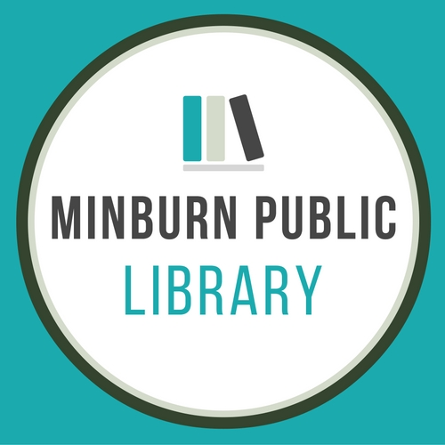

Community

Calendar

11/2- Library Board Mtg 6:30

11/9-City Council Mtg.

11/11- Veteran’s Day Take and Go Supper-5-7pm

11/26-Thanksgiving- City Offices and Library are closed

11/27- City Offices and Library are closed

11/28- Library is closed